Details Investigation [Pre-Claims] Report

INVESTIGATOR DETAILS

Investigation Agency Name | Filed investigator name | Contact Number of field investigator | Investigation Assignment date | Report Submission date |  | Time Taken (TAT)
Virtual Investigation Services | Satyapal | 9161022060 | 22.07.2026 | 18.08.2026 |  | 27 days
Decision (Positive / Negative) | Positive
Please specify - Meeting with LA done.

PROPOSAL/POLICY DETAILS:
App No | Policy No | Policy Issued Date | Sum Insured | Policy Duration
NA | 80364896 | 22.06.2026 | 1183306 | Around 01 month 27 days

PROPOSAL VERIFICATION:
Personal Details of the Insured’s (Age, Income, Reason & Occupation – Nature of Duties)
Details – As per | In Proposal Form | During Profile check | Discrepancy noted (Yes/No) | Evidence received (YES/NO) | Specify evidence
Name | Ravi Kumar | Ravi Kumar | NO | No | Not Shared
Date of birth (Age) | 02.09.2012 | 02.09.2012 | No | NO | NA
Income | NA | NA | NO | NO | NA
Occupation | Student | Student | NO | No | NA
Work Place Address | NA | NA | NA | NA | NA
Health, Hospitalization details (past hospitalization details-if any) | NA | NA | NA | NA | NA
Marital Status | Unmarried | Unmarried | NO | No | As per LA
Qualification/Education | Studying in Class 10th | Studying in Class 10th | NO | No | As per LA
Address | Megwalon ki basti, sam Jaisalmer, JODHPUR, Rajasthan, 345001 | Megwalon ki basti, sam Jaisalmer, JODHPUR, Rajasthan, 345001 | NO | NO | NA
Nominee/Beneficiary | Not sure | NA | No | No | No
PEP – Political exposed person | Not Found | Not Found | Not Found | Not Found | Not Found
Hazardous hobbies – if any | Not Found | Not Found | Not Found | Not Found | Not Found
Please specify in detail if any considerable difference/discrepancy in above details with category (eg: age)

[In case of Life assured and Proper are different, please provide Proper name and other details, collect relationship proof also]

FAMILY HISTORY:
Sr. No. | Name of family Member | Relation with insured | Age of Member | Occupation of family member | Income of family member | Health of family member | Family member KYC Proof
1 | Ravi Kumar | Life assured | 12 Years | Student | NA | Fit |  | Yes
2 | Family member | Father | NA | NA | NA | Fit |  | NA
3 | Family member | Mother | NA | Fit | NA | NA |  | NA
4 | Family member | Brother | NA | Fit | NA | NA |  | NA
Please specify in detail if any considerable difference/discrepancy in above details

OTHER POLICY DETAILS & FAMILY INSURANCE DETAILS (Life/ Mediclaim/ Critical Illness):

Sr. | Name of Company  (Along Health Insurance Cover details) | Name of Life Insured / Proposer | Contract / Proposal no | Basic Sum Insured | RCD | Policy status  ( In-force / Lapsed /Applied/decline/Withdrawn/Rated up/Postpone )
1 | Life - XXXXXXX | Not Disclosed | Not Disclosed | Not Disclosed | Not Disclosed | Not Disclosed
1 | Health – XXXXXXX | Not Disclosed | Not Disclosed | Not Disclosed | Not Disclosed | Not Disclosed
VICINITY CHECK:
(Discussion and conclusion made out of verification done with Relatives/neighborhood, nearby house)
Sr. No. | Name of the person | Relation with insured | Contact No | Address
1 | Vinod Kumar | Nearby People | NA | JODHPUR
2 | Nitin | Nearby People | NA | JODHPUR
Findings/Observation/remarks:
- IO visited the nearby location of the mentioned address and met with local people.
- IO inquired about the mentioned address and the Life Assured (LA); however, local people were not aware of either.
- Local people stated that the mentioned address was incomplete, as no house number was provided.
- IO made his best efforts to locate the address, but the provided address could not be traced.

Workplace Check:
Sr. No. | Name of the Person met | Relation (Manager, HR, Friends etc.) | Contact No of person met | Conversation details and statements
1 | NA | NA | NA | NA
2 | NA | NA | NA | NA
(A) In case of Salaried:
- Name of employer: NA
- Life Assured designation and income, general health/habit, behavioral- NA
- Salary slip/Income Tax Return/Form 16: NA
- Sick Leave details, Reason for availing sick leaves, collect medical documents, duly filled employer certificate to be collected: NA

(B) In case of business/self-employed/Shop/Vendor: (Contact at least 2-3 adjacent shop owners, colleagues, friends record their statement in writing & contact no.) –
Photo of Shop/Business -

Findings/Observation/remarks (if any mismatch/discrepancy noted with regard to age, occupation, income, health, habit, …)
- During the investigation, IO came to know LA’s financial condition is Middle.
- During investigation, Investigator found that LA is fit & healthy.
News Paper / Internet check:
Name of documents/  Information. Eg: Voter id Card, ITR etc. ) | Snapshot taken and attached with report | Findings
By Visit/Verification- |  | NA
By Online Checks - | This needs to done by online Checks - Linked In / Business Registration Proof, Website checks. (Ration Card, Voter id Search for age difference suspected profile) | NA

Investigation Agency Overall findings:
**Overall Remarks: **
First Visit:
- IO tried his best to locate the address, but provided address was not traceable.
- IO make a call to LA on provided number and the call was picked by LA.
- IO told that he is an investigating officer on behalf of Kotak Life insurance and asked for policy verification visit.
- On call, LA denied for any kind of verification.
- LA has not shared any details over the call and has not confirmed his address.
- LA was not cooperative during verification call LA was not cooperative during the verification call and did not provide the required information and documents.

Second Visit
- IO got a call from LA, he confirms the address and he schedule the visit for verification.
- IO visited at mentioned address and met with LA.
- IO introduced himself and asked for policy verification. Life assured has shared required verification details over call.

**Other information not covered in the report above: **
- During the investigation, LA shared that currently he is studying in class 10th.
- LA is unmarried.
- LA stated that his father manages his own hotel business but not sure about annual income.
- He stated that her family has 06 members, with 01 earning members.
- LA has shared his Aadhar card as a KYC proof which is attached with this proof.
- LA informed that he is not sure about policy premium, nominee and the term.
- When asked about his health condition, LA stated that he has no medical issues or has no any type of addiction.

DOCUMENTS PROCURED / COLLECTED:
Particulars | Evidence Collected by investigator
Age Proof | Aadhar card
Occupation and Income Proof | Student
Customer Live Photo, Workplace Photo | Attached
Medical Evidence – If any | No
Other Insurance policy - If any | NA
Death Certificate (if applicable) | NA
Family/Nominee KYC (Age/identity) | NA
List are for reference only, change as per procured documents

First Visit
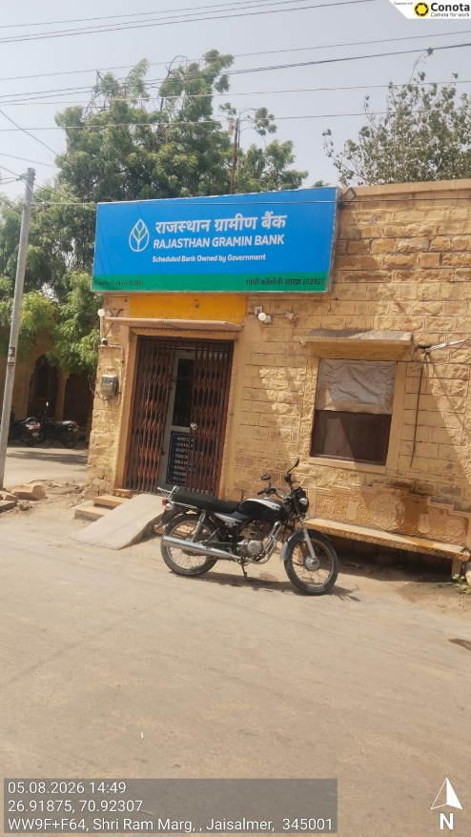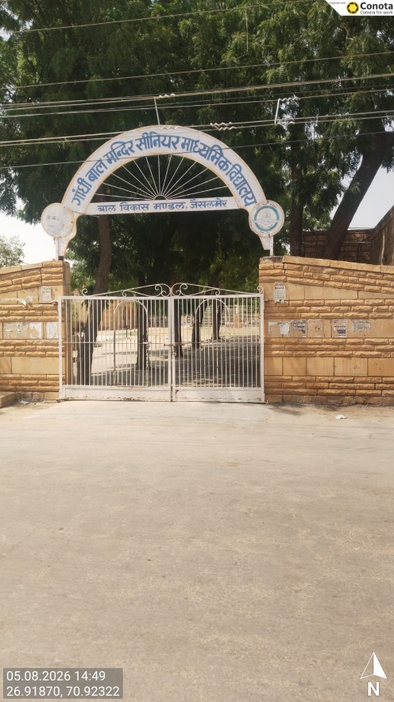
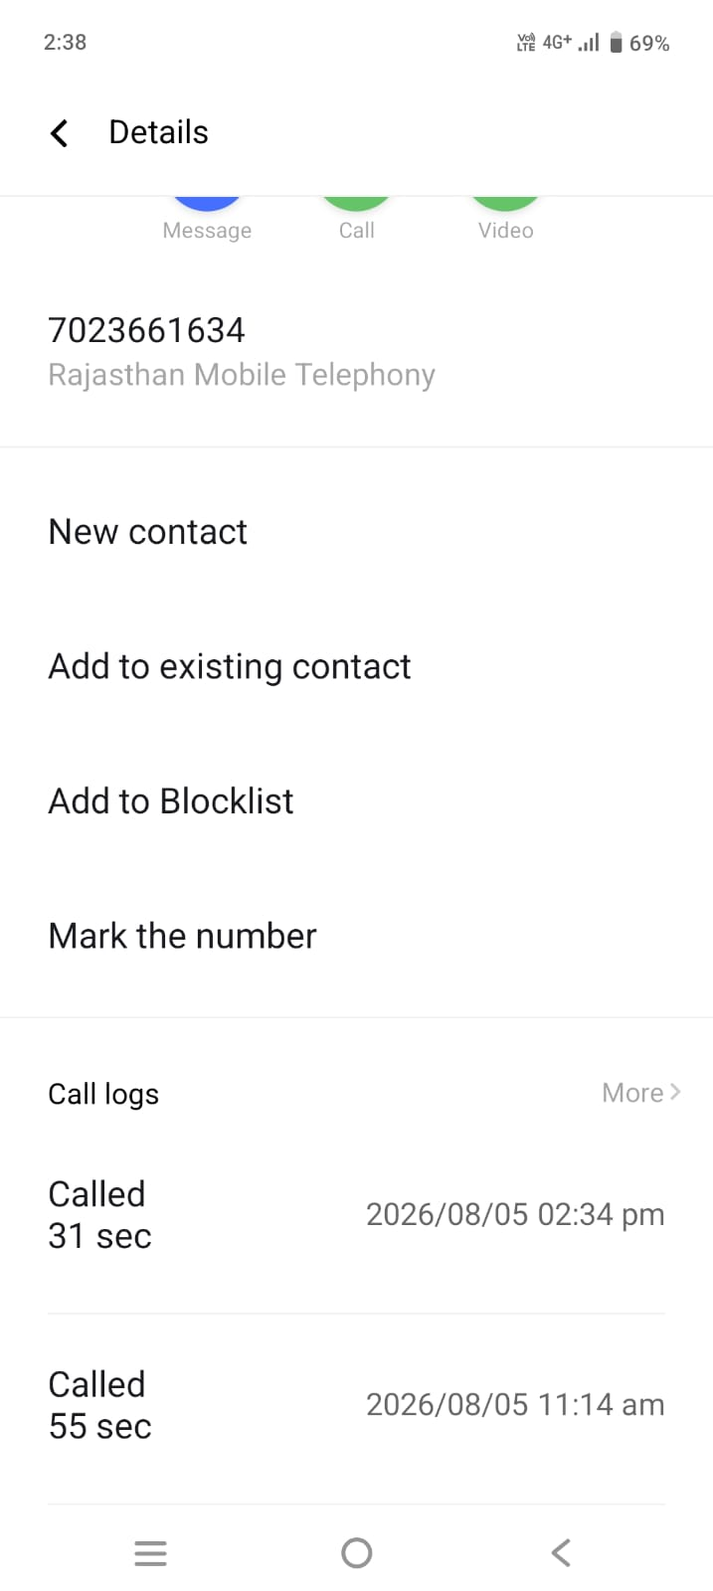

Second Visit

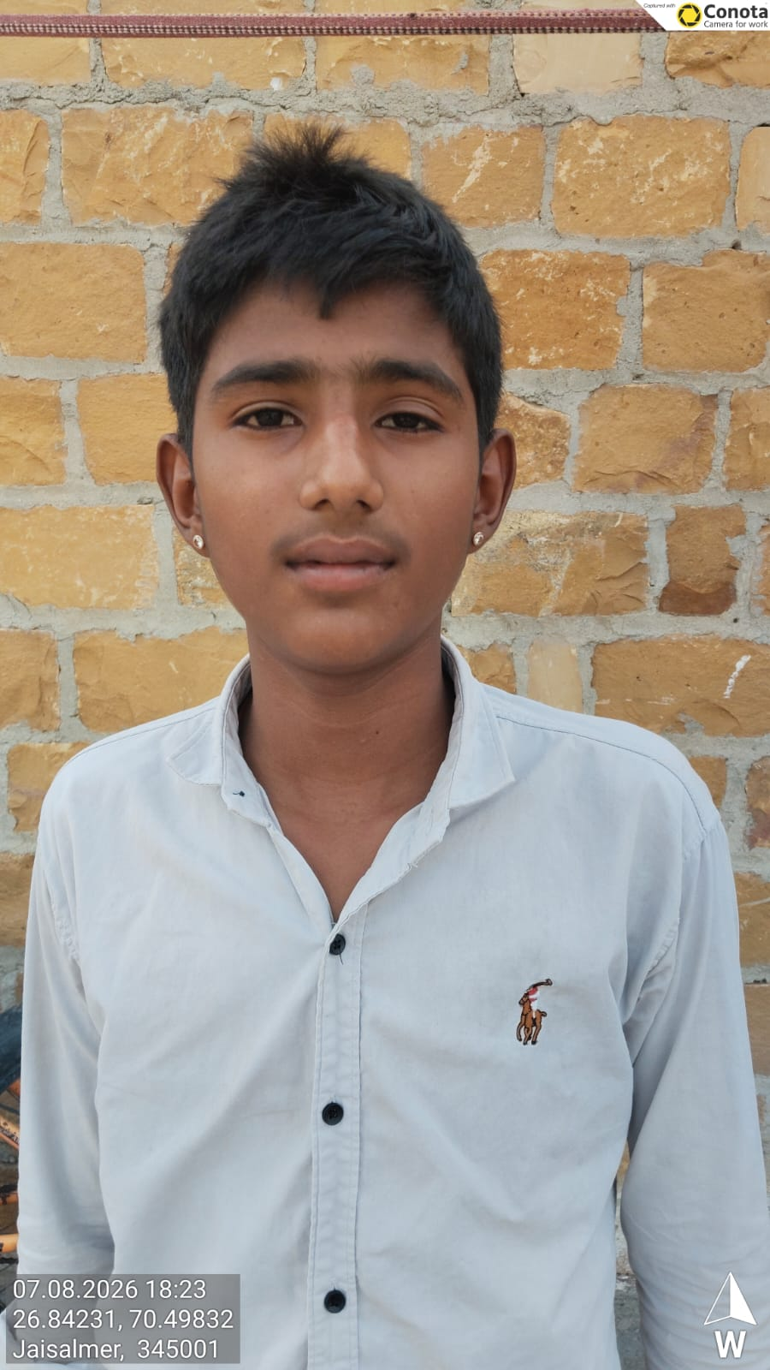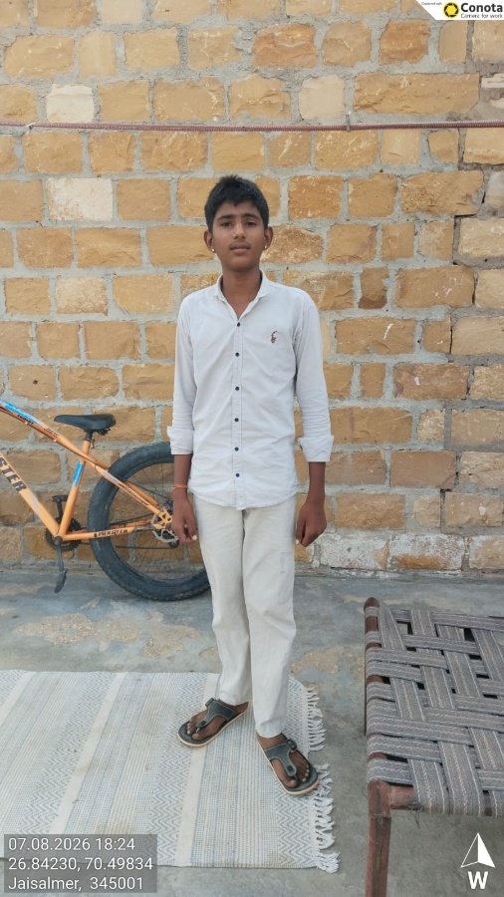
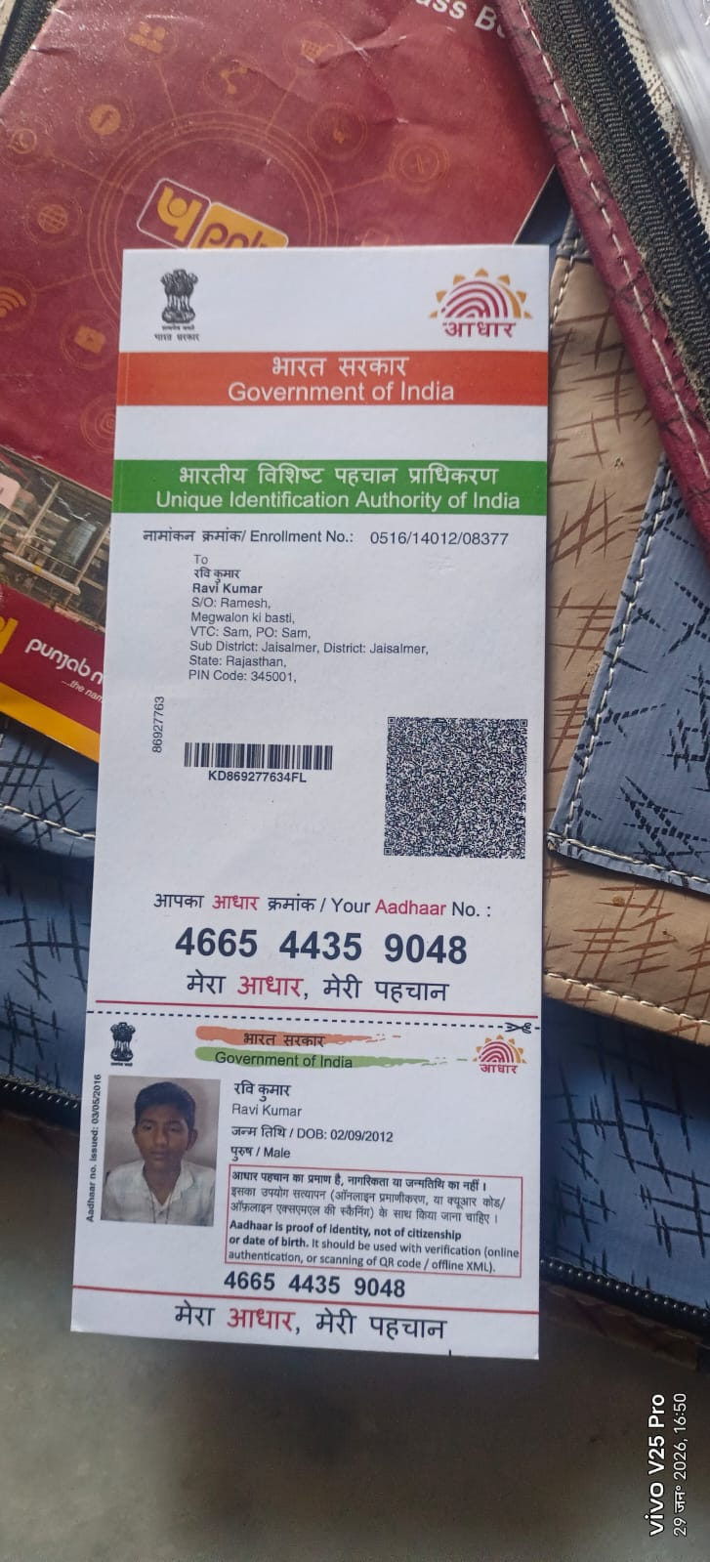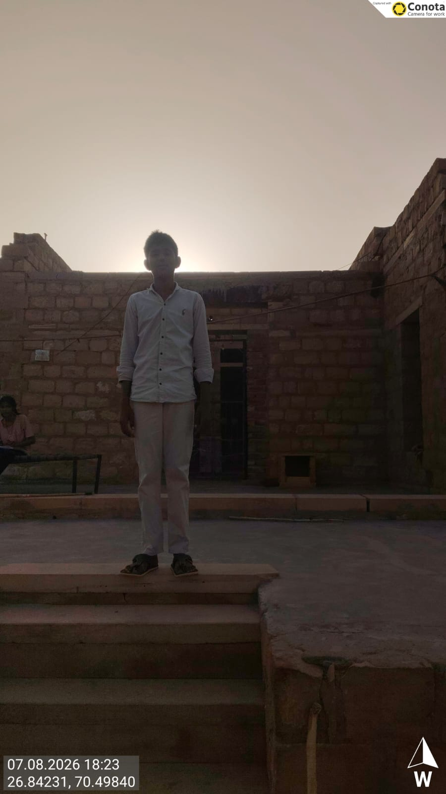
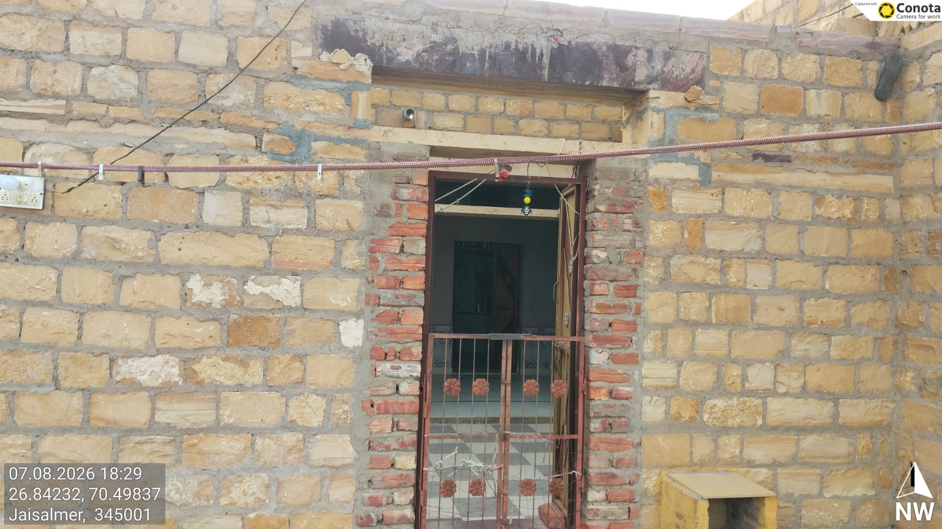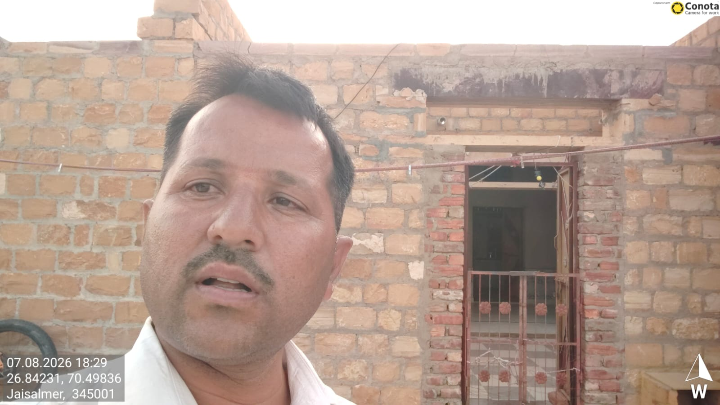

END

